



RT-4588-01

DoseMax™ Standalone Device

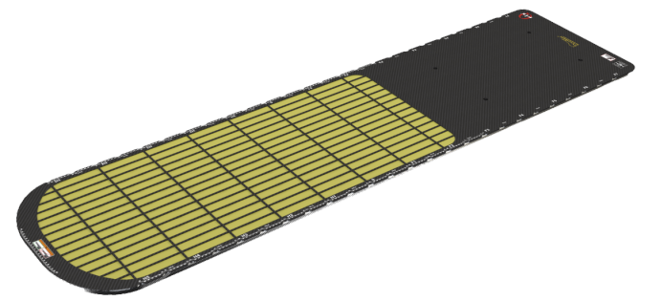

|  |  |  |
| --- | --- | --- |
| Product Name |  | DoseMax Standalone Device |
| Product Number | | RT-4588-01 |
| General Description | | Patient Positioning System |
| Indications for Use | | This device is intended to immobilize, position and reposition patients undergoing radiation therapy |

|  |  |
| --- | --- |
| Technical Details | |
| Materials | Foam Cored Composite |
| MR Compatibility | NOT MR Compatible |
| Weight (Approx.) | 6.5 kg (14 lbs) |
| Patient Weight Capacity | 249 kg (550 lbs) |
| Dosimetric Properties | Water Equivalence: 2.0 mm @ 6 MV |
| Technical Drawing |  |
|  | |

DoseMax™ Standalone Device

DoseMax is a trademark of Qfix.